Food Delivery Cost and Profitability Analysis Report

# Introduction

The Food Delivery Cost and Profitability Analysis project aims to understand and optimize the financial dynamics of a food delivery operation. By examining all costs associated with delivering food orders—from direct expenses like delivery fees and packaging to indirect expenses like discounts offered to customers and commission fees paid by restaurants—and juxtaposing these costs against the revenue generated, the analysis provides insights into how profitable the service is on a per-order basis. This project is designed to help identify areas where the service can reduce costs, increase revenue, and implement pricing or commission strategies that enhance profitability.

# Process Overview

The analysis follows a structured process to ensure comprehensive evaluation and actionable insights:

1. Data Collection: Gather comprehensive data related to all aspects of food delivery operations.
2. Data Cleaning and Preparation: Clean the dataset to handle inconsistencies, missing values and irrelevant information.
3. Feature Extraction: Extract relevant features that impact cost and profitability.
4. Cost Breakdown: Break down costs associated with each order, including fixed and variable costs.
5. Revenue Calculation: Determine the revenue generated from each order, focusing on commission fees and order values.
6. Profit Calculation: For each order, calculate profit by subtracting total costs from revenue.
7. Profitability Analysis: Analyze the distribution of profitability across all orders to identify trends.
8. Strategic Recommendations: Develop recommendations aimed at enhancing profitability.
9. Financial Simulation: Use the data to simulate the financial impact of proposed changes, such as adjusting discount or commission rates.

# Data Collection

The dataset for this analysis contains 1,000 entries and 12 columns, with no missing values. It includes detailed information on order IDs, customer IDs, restaurant IDs, order and delivery timestamps, order values, delivery fees, payment methods, discounts, commission fees, payment processing fees, and refunds/chargebacks.

# Data Cleaning and Preparation

Several data cleaning steps were performed to ensure the dataset's accuracy and consistency:

* Converted "Order Date and Time" and "Delivery Date and Time" to datetime format.
* Calculated discount amounts from the "Discounts and Offers" column.
* Ensured all monetary values were in a suitable format for calculations.

# Cost and Profitability Analysis

## Cost Breakdown

The following costs were considered for each order:

* Delivery Fee: Fee charged for delivering the order.
* Payment Processing Fee: Fee for processing the payment.
* Discount Amount: Discount provided on the order.

## Revenue Calculation

Revenue for the platform is primarily derived from commission fees charged to restaurants.

## Profit Calculation

Net profit for each order was calculated by subtracting total costs from revenue. The analysis of overall metrics revealed:

* Total Orders: 1,000
* Total Revenue (from Commission Fees): 126,990 INR
* Total Costs: 232,709.85 INR (including delivery fees, payment processing fees, and discounts)
* Total Profit: -105,719.85 INR

## Profitability Analysis

The analysis indicated that the total costs associated with food delivery operations exceed the total revenue generated from commission fees, resulting in a net loss. This suggests that current commission rates, delivery fees, and discount strategies might not be sustainable for profitability.

### Visualizations:

### Histogram of Profits per Order:

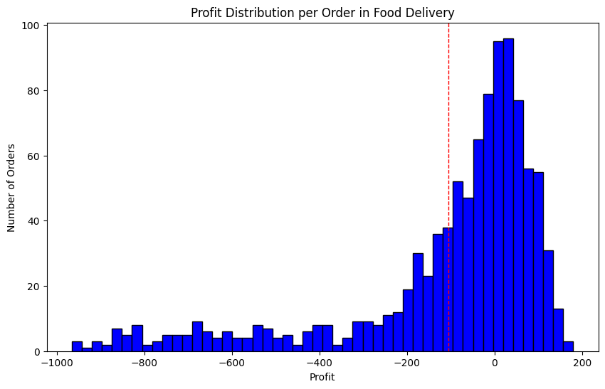

The histogram shows a wide distribution of profit per order, with a significant number of orders resulting in a loss.

### Pie Chart of Total Cost Proportions:

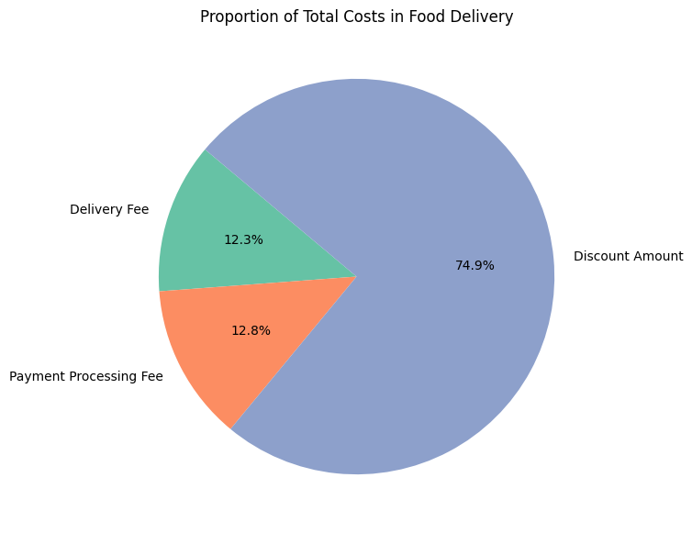

The pie chart illustrates the breakdown of total costs into delivery fees, payment processing fees, and discount amounts. Discounts constitute a significant portion of the costs.

##### Bar Chart of Total Revenue, Costs, and Profit:

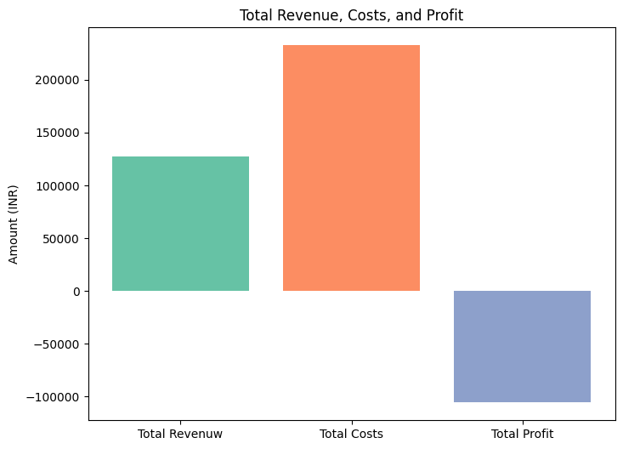

The bar chart visually represents the gap between revenue and costs, clearly showing that costs surpass revenue, leading to a total loss.

# A New Strategy for Profits

To move towards profitability, a new strategy focusing on optimal commission and discount rates is necessary. By analyzing profitable orders, the following average rates were identified as potential sweet spots:

* New Average Commission Percentage: 30.51%
* New Average Discount Percentage: 5.87%

## Financial Simulation

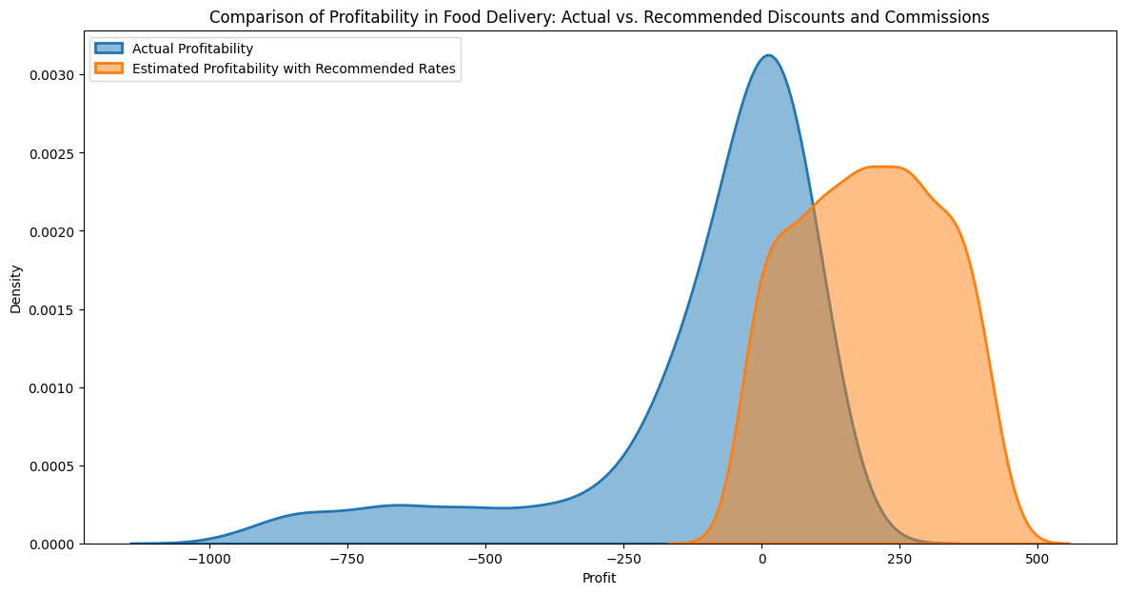

Simulating profitability with the recommended adjustments showed a potential shift towards higher profitability per order. The comparison indicated that the recommended adjustments could lead to a higher proportion of profitable orders.

# Summary and Recommendations

This comprehensive analysis revealed that the current operational strategy of the food delivery service is unsustainable due to excessive costs, primarily driven by high discount rates. To enhance profitability, the following recommendations are made:

1. Adjust Commission Rates: Increase commission rates to around 30%.
2. Reduce Discount Rates: Limit discounts to approximately 6%.

By implementing these strategies, the service can improve its overall profitability and ensure a more sustainable business model. This analysis serves as a blueprint for food delivery businesses seeking to optimize their cost structures and enhance financial performance.

# Conclusion

Food Delivery Cost and Profitability Analysis involves a meticulous examination of all costs associated with delivering food orders and comparing them against the generated revenue. This analysis has provided valuable insights into the financial health of the food delivery service, highlighting areas for improvement and suggesting strategic changes to achieve profitability. By following the recommended strategies, food delivery businesses can optimize their operations and move towards a more profitable and sustainable future.